USP5 Computational Project Report
Summary of the modeling, enumeration, and lead selection workflow.
2026-03-29

Executive Summary
- The project now has one canonical computational pipeline built around a saved ExtraTrees regression model, a broad 10-method enumeration library, and a multistage lead-selection funnel.
- The final saved potency model achieved in-sample R^2 = 0.893 on the current row-level USP5 dataset and remains the project-level potency engine.
- The broad enumeration workflow produced 3264 unique virtual compounds from the positive training chemistry space.
- The final screening pipeline narrowed 3274 total structures (broad enumeration plus original positives) to 4 strict primary leads and 5 orthogonal backup leads.
- Most computational cheminformatics work is complete; the main remaining tasks before paper writing are figure assembly, polished results framing, and ideally experimental validation planning.

Project Aim
The goal of this project is to build a practical small-data USP5 inhibitor discovery workflow that combines potency modeling, chemically meaningful virtual enumeration, and computational lead prioritization. The emphasis is on transparent and interpretable cheminformatics rather than black-box modeling.

Dataset Status
- Raw input file: data/raw/First.csv
- Valid row-level entries used by the final model: 26
- Deduplicated canonical molecules in the modeling table: 19
- The dataset mixes measured activity rows with assigned active/inactive labels; this is tracked explicitly in the cleaned outputs.

Modeling Dataset Overview
representative_id | target_pIC50 | target_origin | has_measured_row | has_active_no_ic50_row | has_inactive_row
CHEMBL5278336 | 5.15 | measured_median | True | False | False
CHEMBL1410015 | 4.62 | measured_median | True | False | False
CHEMBL2012938 | 5.23 | mixed_duplicate_measured_median | True | True | False
CHEMBL1923233 | 5.52 | measured_median | True | False | False
CHEMBL5276142 | 4.67 | measured_median | True | False | False
CHEMBL1493046 | 4.54 | measured_median | True | False | False
CHEMBL4635160 | 5 | measured_median | True | False | False
CHEMBL5410606 | 5.1 | measured_median | True | False | False
CHEMBL5267683 | 3.7 | measured_median | True | False | False
CHEMBL4129140 | 3.7 | measured_median | True | False | False
51031028 | 2.5 | assigned_median | False | False | True
443118 | 2.5 | assigned_median | False | False | True
10216098 | 2.5 | assigned_median | False | False | True
49864402 | 2.5 | assigned_median | False | False | True
25191039 | 5 | assigned_median | False | True | False
70691637 | 5 | assigned_median | False | True | False
73353602 | 2.5 | assigned_median | False | False | True
145963683 | 5 | assigned_median | False | True | False
168007234 | 2.5 | assigned_median | False | False | True

Final Potency Model
The final potency model is the saved ExtraTreesRegressor reported in outputs/final_model/final_model_report.md. This model was deliberately preserved as the canonical project model for all final screening.
- Model family: ExtraTreesRegressor
- Feature block: physicochemical descriptors plus graph-topology descriptors
- Reported in-sample R^2: 0.893359
- Reported MAE: 0.176795
- Reported RMSE: 0.368224
- Model artifact: outputs/final_model/final_model.joblib
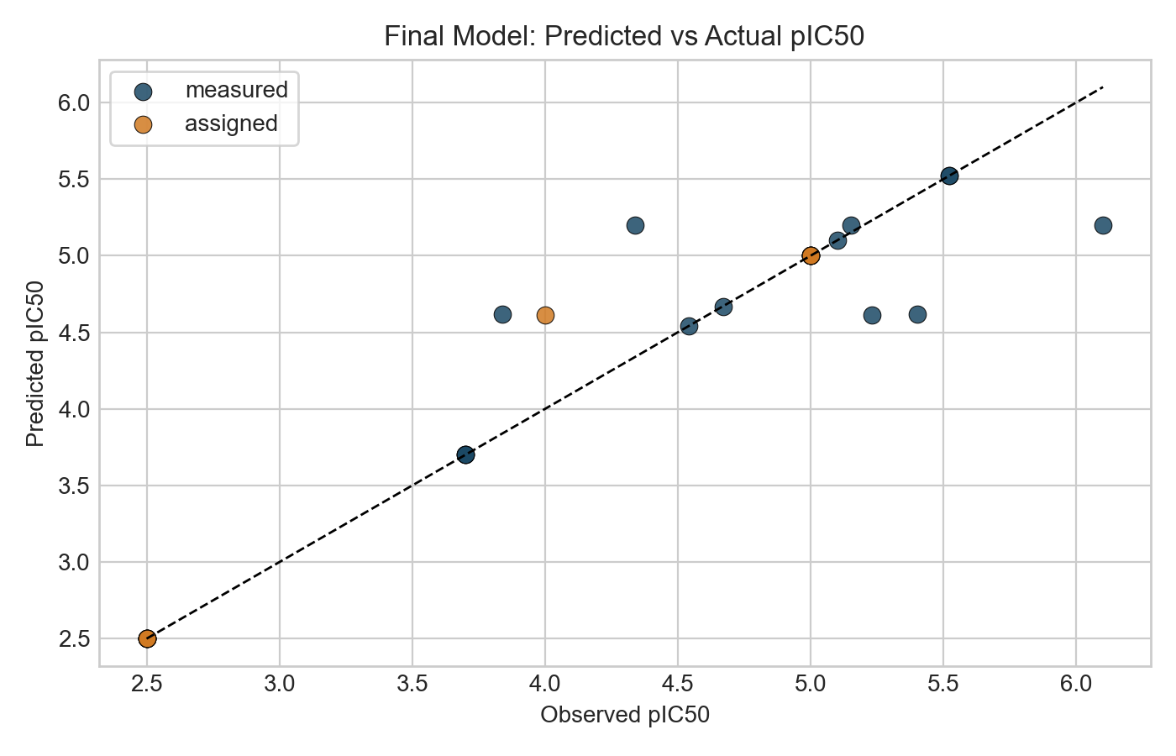
Final model predicted vs observed pIC50
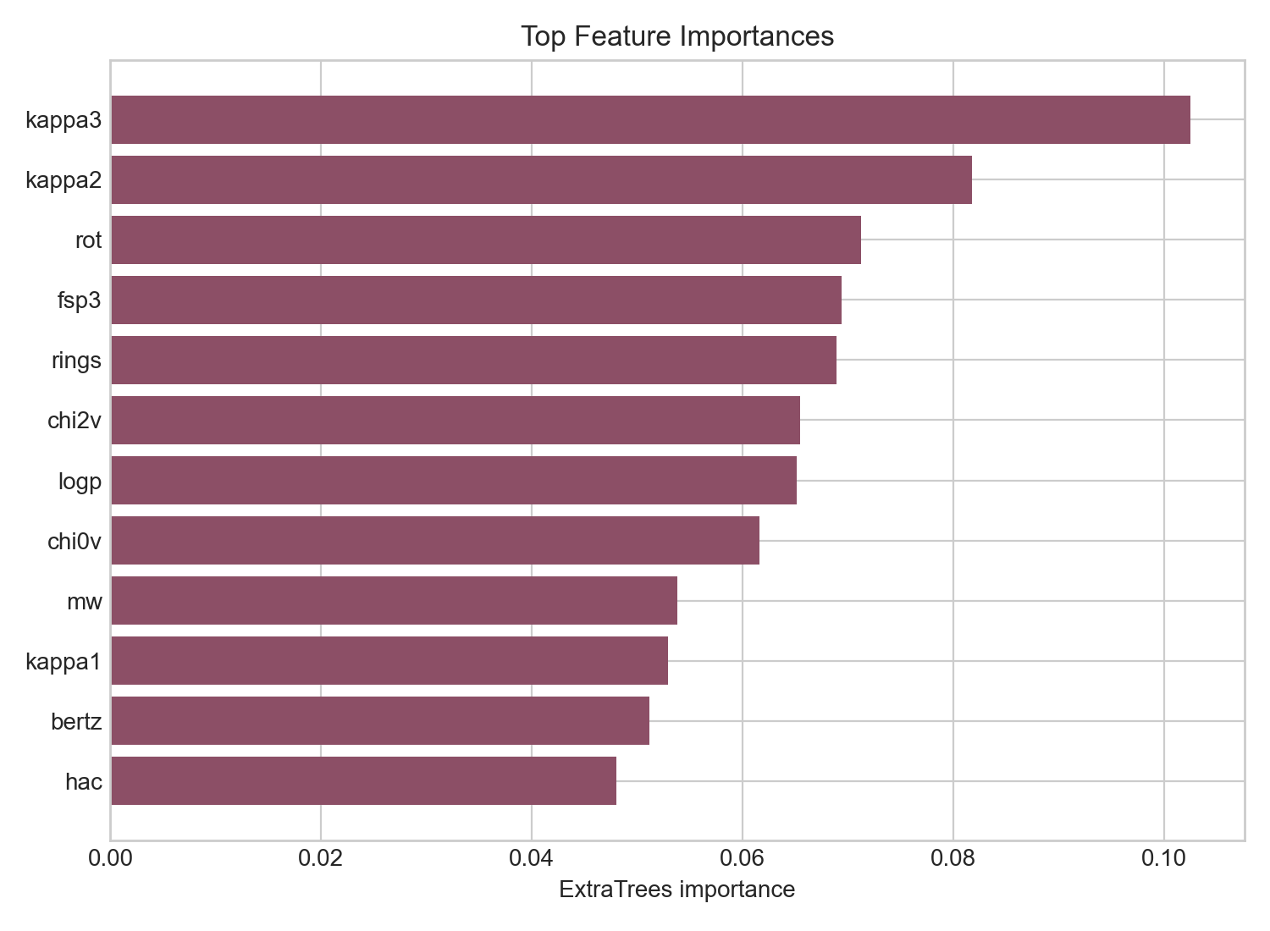
Top feature importances in the final model

Enumeration Workflow
The final enumeration layer is the broad 10-method chemistry workflow. This is the canonical virtual library generation stage used for downstream lead screening.
- Canonical enumeration script: scripts/run_enumeration_10_methods.py
- Canonical broad library: outputs/enumeration_library_10_methods.csv
- Total unique enumerated products: 3264

Enumeration Method Breakdown
method | count
r_group_enumeration | 1205
reagent_pool_combinatorics | 1200
scaffold_hopping | 671
fragment_growing | 430
heteroatom_walks | 61
reaction_based_enumeration | 31
matched_molecular_pair_expansion | 25
bioisosteric_swaps | 15
linker_scans | 5
ring_size_and_ring_system_scans | 3

Final Lead Selection Workflow
The canonical lead-selection workflow restores the saved final ExtraTrees model as the sole potency engine, then applies property filtering, ADMET-AI, and multistructure USP5 3D template-docking / pharmacophore plausibility.
- Canonical screening script: scripts/run_lead_selection.py
- Property filters include Lipinski-style limits, TPSA, molecular surface area, flexibility, and charge sanity.
- ADMET stage uses ADMET-AI with AMES, hERG, ClinTox, HIA, oral bioavailability, permeability, and solubility-related outputs.
- 3D structural evidence uses USP5 ZnF-UBD co-crystal structures 6DXT, 7MS5, 7MS6, and 7MS7.
- The final output is split into primary leads and orthogonal backup leads to avoid overclaiming a single chemotype as the only viable program.

Lead Selection Funnel
stage | count
start_broad_enumeration_plus_original_positives | 3274
stage1_original_final_model_predicted_pIC50_ge_4.60 | 1272
stage2_pains_brenk_free | 772
stage3_lipinski_psa_surface_area_flexibility | 59
stage4_admet_ai_multigate | 24
stage5_multistructure_template_docking_strict | 4
stage5b_multistructure_template_docking_relaxed | 5

Primary Leads

Canonical Primary Lead Set
product_smiles | primary_parent_id | pred_pIC50 | pred_ic50_uM | AMES | hERG | best_binding_score | scaffold
O=C(O)CNC(=O)c1ccc(S(=O)(=O)N2CCC(c3ccc(Cl)cc3)CC2)cn1 | CHEMBL5278336 | 5.1967 | 6.3582 | 0.0796 | 0.2134 | 0.7818 | O=S(=O)(c1cccnc1)N1CCC(c2ccccc2)CC1
O=C(O)CNC(=O)c1ncc(S(=O)(=O)N2CCC(c3ccc(Cl)cc3)CC2)cn1 | CHEMBL5278336 | 4.8951 | 12.7309 | 0.0537 | 0.1057 | 0.8298 | O=S(=O)(c1cncnc1)N1CCC(c2ccccc2)CC1
O=C(O)CNC(=O)c1ccc(S(=O)(=O)N2CCC(c3ccc(F)cc3)CC2)cn1 | CHEMBL5278336 | 5.011 | 9.7504 | 0.0975 | 0.1226 | 0.7799 | O=S(=O)(c1cccnc1)N1CCC(c2ccccc2)CC1
O=C(O)CNC(=O)c1ccc(S(=O)(=O)N2CCC(c3ccc(Cl)cn3)CC2)cn1 | CHEMBL5278336 | 4.895 | 12.7356 | 0.0355 | 0.1308 | 0.7617 | O=S(=O)(c1cccnc1)N1CCC(c2ccccn2)CC1

Orthogonal Backup Leads

Canonical Backup Lead Set
product_smiles | primary_parent_id | pred_pIC50 | AMES | hERG | best_binding_score | scaffold
COc1ccccc1CNC(=O)Cn1c(CCC(=O)O)nc2c(Cl)cccc2c1=O | CHEMBL5410606 | 5.1 | 0.1284 | 0.2254 | 0.3503 | O=C(Cn1cnc2ccccc2c1=O)NCc1ccccc1
COc1ccccc1CNC(=O)Cn1c(CCC(=O)O)nc2c(F)cccc2c1=O | CHEMBL5410606 | 5.0192 | 0.1279 | 0.1607 | 0.3975 | O=C(Cn1cnc2ccccc2c1=O)NCc1ccccc1
Cc1cc(-c2cc(C)n(CCC(=O)O)c2C)c(C)n1CCC(=O)O | [9*]n1c(C)cc([16*])c1C | 4.8743 | 0.0932 | 0.1127 | 0.5561 | c1cc(-c2cc[nH]c2)c[nH]1
Cc1cc(-n2c(C)cc(CCC(=O)O)c2C)c(C)n1CCC(=O)O | [9*]n1c(C)cc([16*])c1C | 4.8758 | 0.0681 | 0.0676 | 0.4997 | c1ccn(-c2cc[nH]c2)c1
COc1ccccc1CNC(=O)Cn1c(CCC(=O)O)nc2c(Cl)cncc2c1=O | CHEMBL5410606 | 4.8769 | 0.0639 | 0.1786 | 0.4151 | O=C(Cn1cnc2ccncc2c1=O)NCc1ccccc1
COc1ncccc1CNC(=O)Cn1c(CCC(=O)O)nc2c(Cl)cccc2c1=O | CHEMBL5410606 | 4.8761 | 0.0736 | 0.0731 | 0.346 | O=C(Cn1cnc2ccccc2c1=O)NCc1cccnc1

Interpretation of Current Results
- The strict primary lead evidence remains concentrated in the CHEMBL5278336 acid-sulfonamide family.
- The backup program retains orthogonal chemistry, especially CHEMBL5410606-derived bicyclic carbonyl analogs and a weaker heteroaryl-acid branch.
- The project now has a consistent folder structure and a single final pipeline rather than multiple competing screening variants.
- From a project-management standpoint, most of the computational chemistry work is now done.

Limitations
- The final model is exploratory and small-data; strong prospective claims should be avoided.
- The final model performance reported here is in-sample rather than a large prospective benchmark.
- The 3D stage is a multistructure template-docking / pharmacophore surrogate, not a full production docking plus MD validation campaign.
- All lead calls remain computational priorities until experimentally tested.
- The dataset includes assigned labels in addition to measured values, which should be acknowledged in any presentation or manuscript.

Work Completed
- Dataset parsing, cleaning, label annotation, and canonicalization
- Descriptor and fingerprint generation
- Baseline similarity and scaffold analysis
- Final exploratory USP5 potency model selection and report generation
- Broad 10-method combinatorial enumeration
- ADMET-AI integration
- Multistructure USP5 3D screening against experimentally determined co-crystal structures
- Primary and orthogonal backup lead prioritization
- Project-folder cleanup and canonical final pipeline consolidation

Next Steps
- Assemble publication-quality figures from the existing outputs
- Freeze the exact final tables and figure order for the manuscript
- Write the Results and Discussion around the canonical final pipeline
- State limitations carefully and explicitly
- Ideally plan or begin experimental validation to strengthen the paper

